

.

Handling, Safety and Installation Instructions
Bastech® rebars are lightweight and highly durable, making them easy to handle and install. Incorrect handling could compromise safety and performance. Please observe the following guidelines for handling, safety and storage.
Shipping and Storage
The manufacturer packages and ships rebar either in coil rolls (up to 8 mm diameter inclusive) or as straight rods (any diameter) up to 12 m long. The straight bar can be supplied arranged in meshes of different size and secured either by a resin adhesive or a plastic tie:
- The coil roll can hold up to 100 m. The coil is tied up along its length by number of ties to hold it together. Coils are packed either in bulk on pallets for shipping or individually, wrapped in film and warning labels applied to alert of a spring loaded product. Coils are clearly labelled with batch number and the length.
- Straight rebar up to the length of 12 meters. Wire tied packs of ten pieces of the same length. The wire ties are applied along the length at every 1 - 1.5 meters, the distance between the last tie and the end of the rebar shall be 10 - 20 cm. Packs are clearly labelled with batch number and the length.
- Meshes of different sizes. Most common size is with bars of 8 and 10 mm, area 2.4 m x 4.8 m. The intersection of the bars are secured either by resin adhesive or a plastic tie
Damage by excessive force and/or heavy impacts may occur so observe the following best practices:
- Never store or place on sharp edges or surfaces.
- Meshes: lift using underneath bar. Do not lift using upper bars. In case the intersection is broken tie up using plastic cable ties.

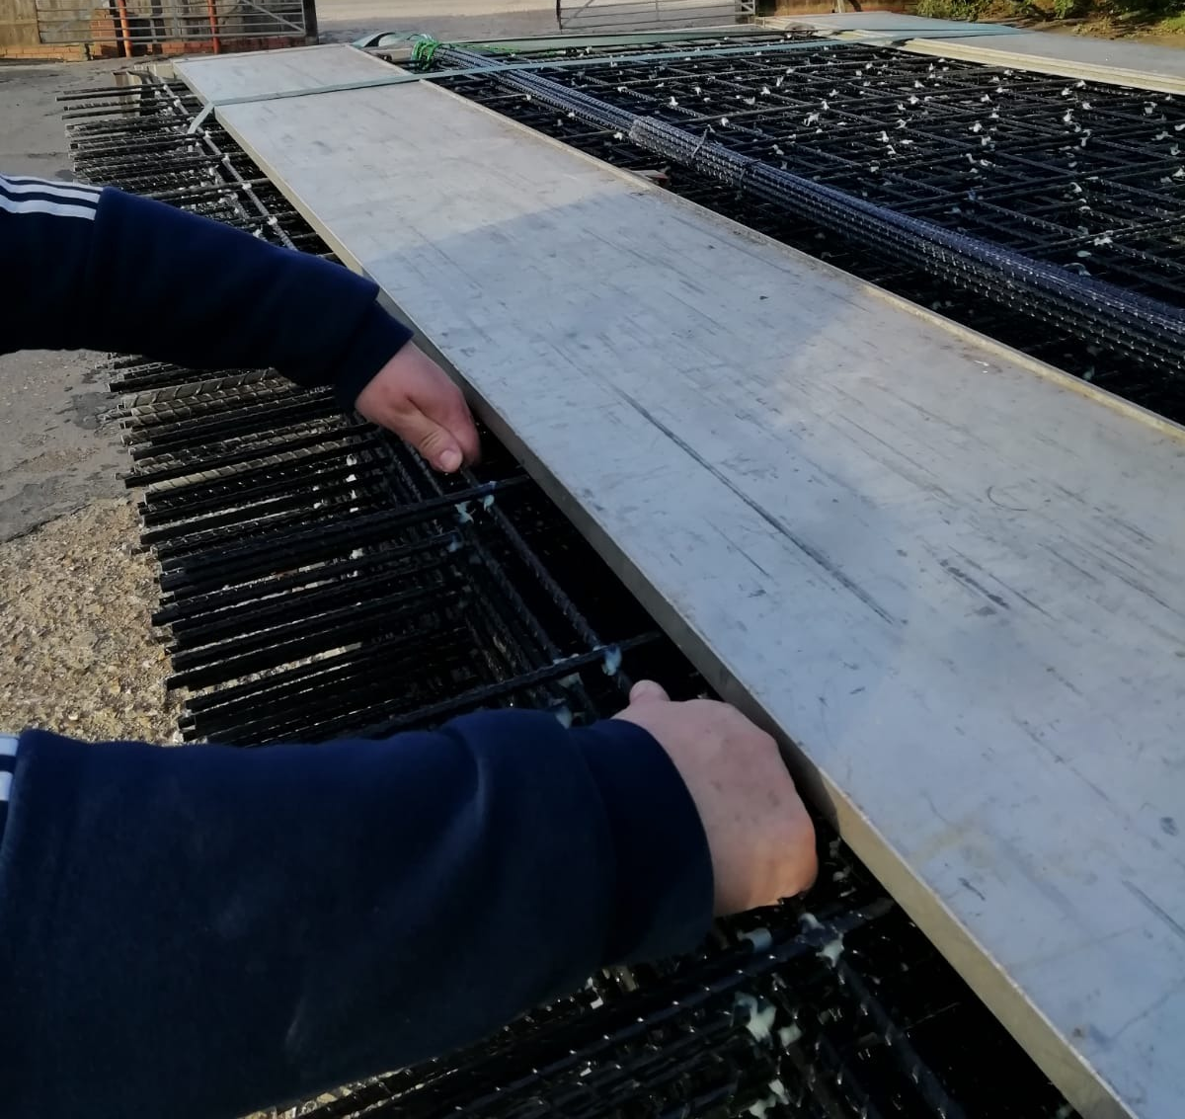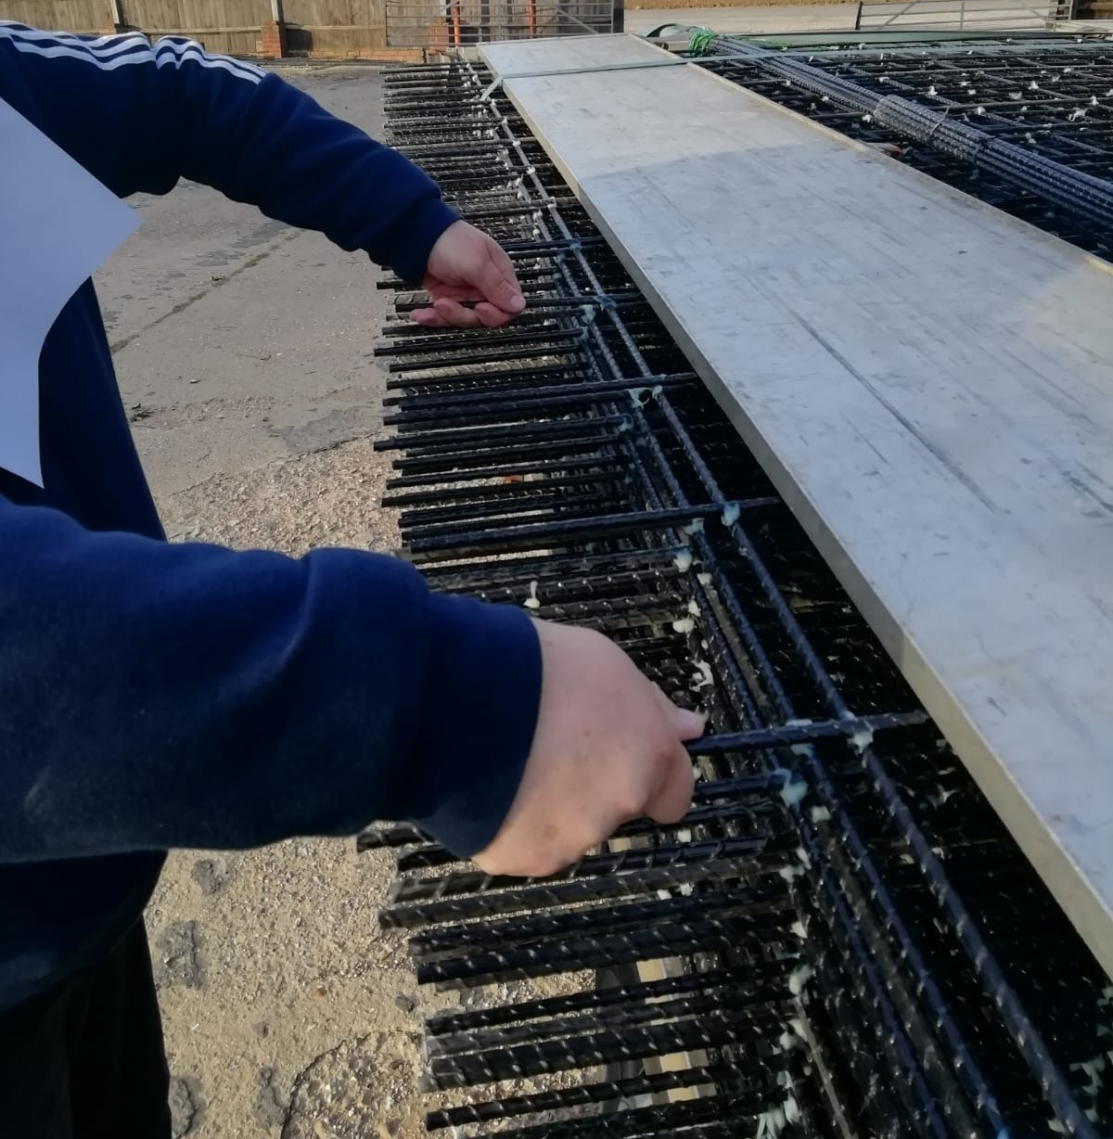
Fig 1. How lift the mesh. Fig 2. How not to lift the mesh.
- Always use proper hoisting equipment and multiple lifting points when handling bundled bars.
- Place bends and non-linear components on durable pallets, use proper lifting and hoisting equipment.
- Store above ground level on platforms, skids, or other supports as close as possible to the point of placement.
- Caution when handling coil rolls as the product is spring loaded. Uncoiling rolls should be done from the inside, exercising great care to prevent instant uncoiling.
Handling
Care is advised in the handling of these materials during storage and installation:
- Open packaging completely and do not force out of packaging.
- Do not drag on the ground or across sharp edges as this can score the Bastech® rebar.
- Damaging or abrading equipment or tooling should not be used with Bastech® rebar.
- On-site cutting is permitted by means of carbide, diamond-coated blades or by hand with a hacksaw. Do not use shears.
- Uncoiling rolls should be done from the inside, exercising great care to prevent instant uncoiling.
- Eye and face protective garments must be worn at all times when cutting Bastech® rebar.
- Gloves must be worn at all times when handling Bastech® rebar, as the surface is treated and designed to facilitate bonding to concrete.
CAUTION: Shape codes are prepared by Basalt Technologies UK Limited and its authorised partners and delivered to the site ready for installation. Bending of bars on site is neither practical nor necessary for very large radius bends. Bastech® rebar can be bent elastically into place and firmly held into position. If released without controls, the elastic energy will cause Bastech® rebar to snap back quickly to its original shape, which may result in injury.

Installation
The placement of Bastech® rebar is similar to that of other rebar. Following these guidelines will ensure the best results:
- Bastech® rebar must be held firmly during the pouring and setting of concrete. Bars, except those to be placed in vertical mats, should be tied at every intersection when the spacing is more than 30cm (12 inches) in any direction. Where the spacing is less than this, the bars should be tied at every intersection or at alternate intersections. Ties maintain the position of the reinforcement during the pouring and setting of concrete. They do not need to provide permanent strength to the structure.
- Always ensure bars do not float upwards and out of position during concrete placement and consolidation. If movement is detected, the pour should be halted whilst additional support or fixtures are added.
- Bastech® rebar is supplied free of materials that could compromise the bond, such as oils, dirt, or chemicals. If the bars become contaminated, they should be cleaned prior to installation to ensure best performance.
- Bastech® rebar can be used and tied in with steel bars. The same tying method as steel should be used in order to achieve best performance.
- Due to the nature of BFRP rebar, shape codes cannot be bent on-site. All shape codes are factory made and delivered to exact specifications. A variety of shapes, stirrups and bespoke bends can be produced
- Chips, scrapes and cuts that do not exceed 5% of the depth of the bar are acceptable. Beyond 5% we recommend replacement of the bar. Alternatively, a lap splice with the appropriate lap length either side of the damage may be applied.
Jointing and lapping
Bastech® rebar may be jointed with lap joints or couplings as shown on the plans. Unless otherwise shown on the plans, Bastech® rebar shall be lap spliced using a BFRP rebar of the same diameter. Lap lengths and bar cover should be as indicated on the plans. The same applies with regards to using couplings which should be applied according to drawing requirement
Additional Information

Please contact Basalt Technologies UK Limited office for any queries on handling, safety and installation. Email: gd@basalt.tech or visit: www.basalt.tech

